During the processing different signals, I have noticed that those signals from circle Sheet have very bad quality that’s why all the data that I have processed is from circle block Sheet. Mean and variance of 1RPM 3 RPM and 5RPM are too shit so I didn’t write them~~

**1RPM**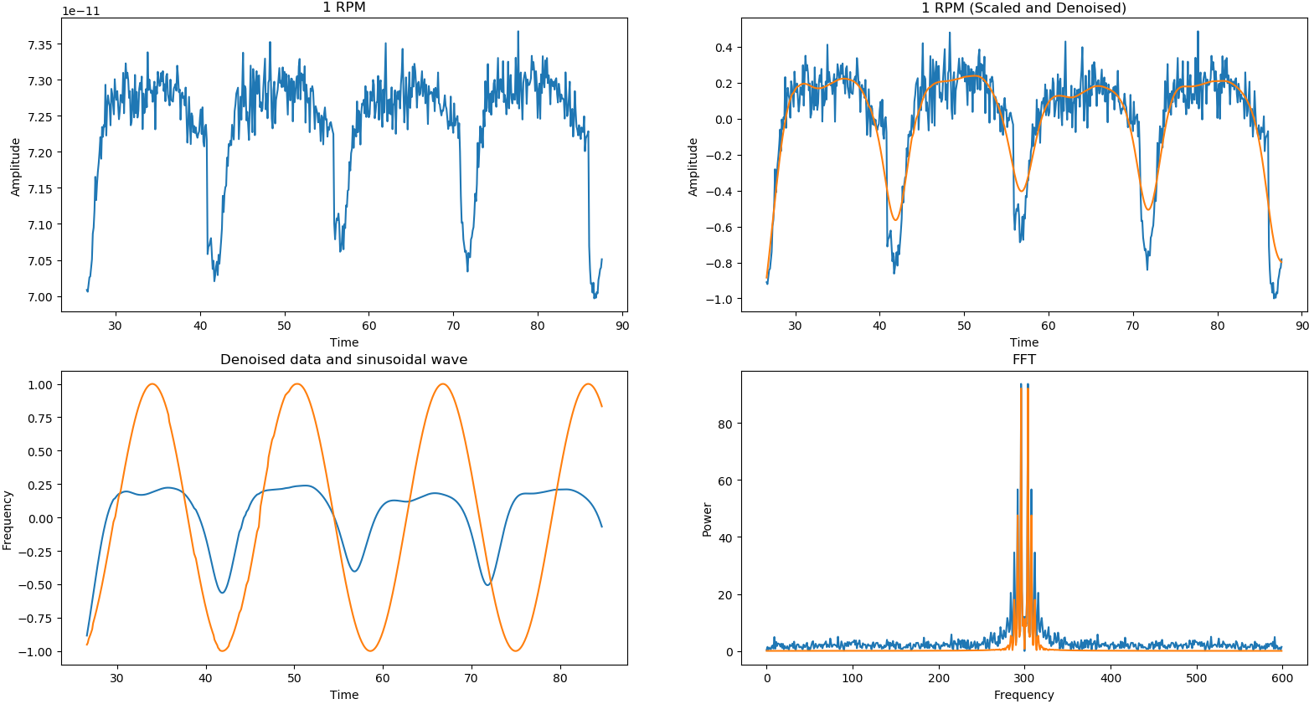

**3RPM**

Optimal window is 5.4 seconds

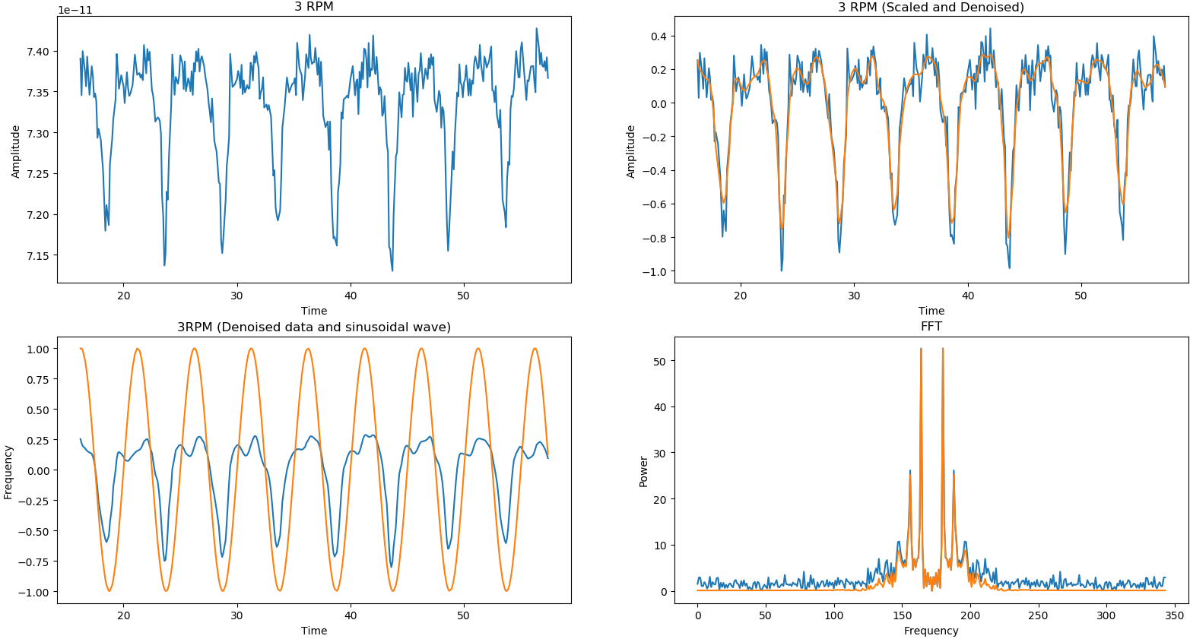

**5RPM**

Optimal window is 4.5 seconds

Mean 27.363636363636363

Var is very big 8.231404958677686

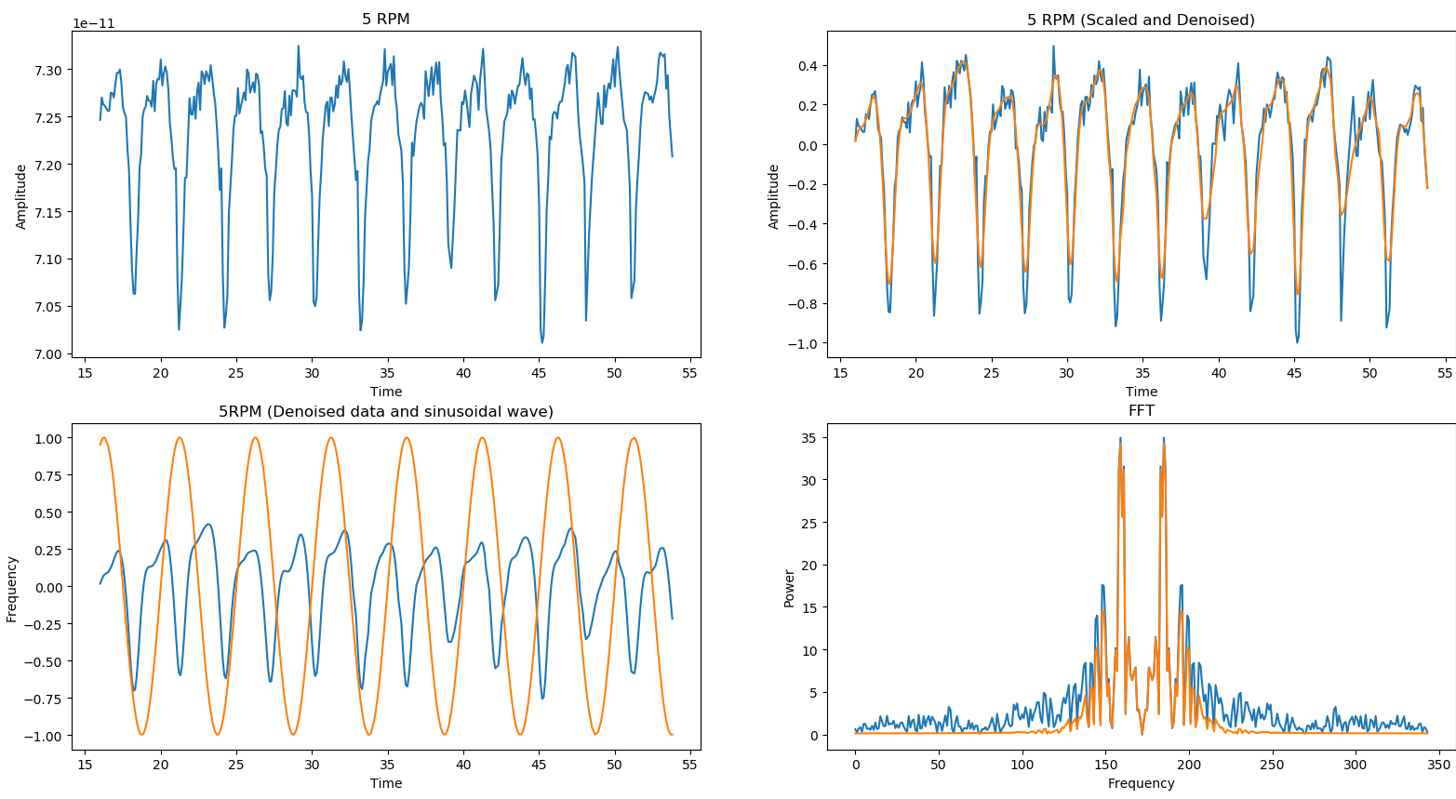

8PRM optimal window is 1.6 sec

Mean 18.6

Var 1.8399999999999999

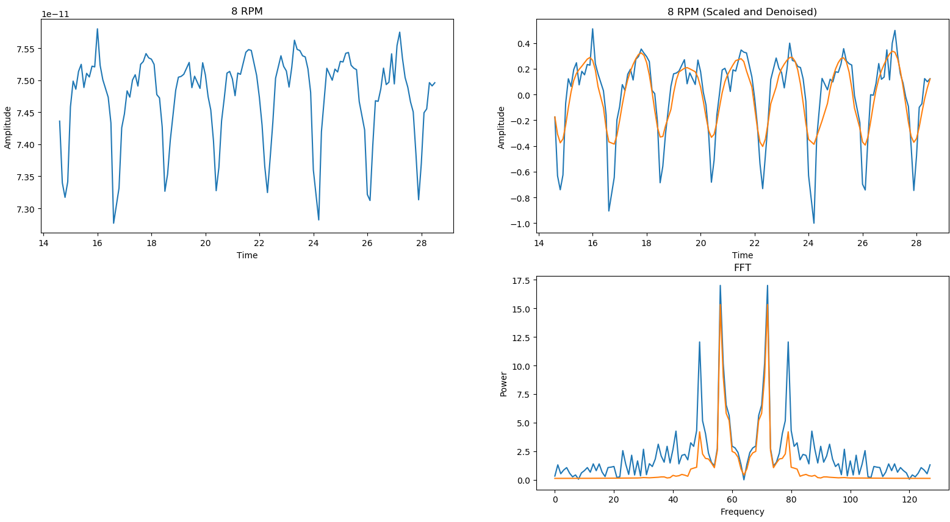

10RPM optimal window is 1.4 sec

Mean 12.555555555555555

Var 1.1358024691358024

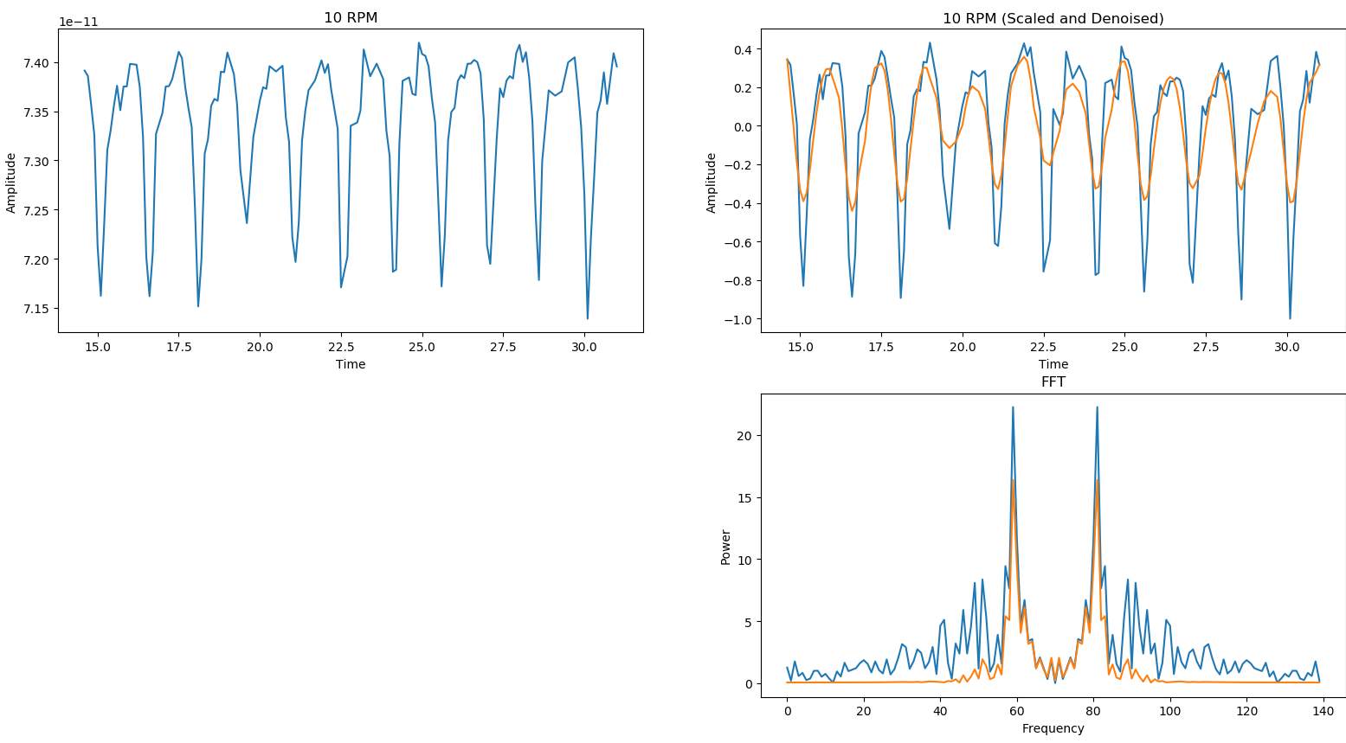

15RPM optimal window is 1 sec

Mean Variance

9.4 0.44000000000000006

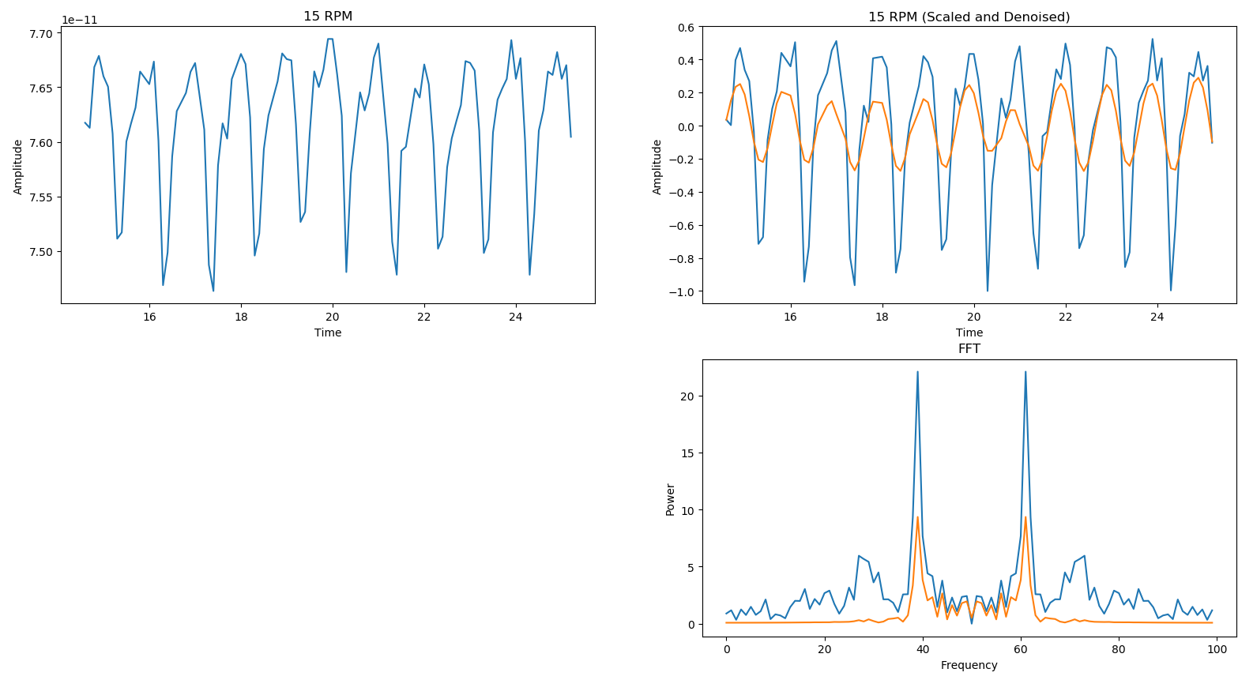

20RPM optimal window is 0.6 sec

Mean and variance

6.222222222222222 1.2839506172839505

HERE I have noticed that some real shit is happening

